ASSIGNMENT 5

Name: P. Sasi Kumar

Register Number: 19210030

Course Code: DSA0163

Course Name: Object Oriented Programming with

c++

USING SINGLE CATCH

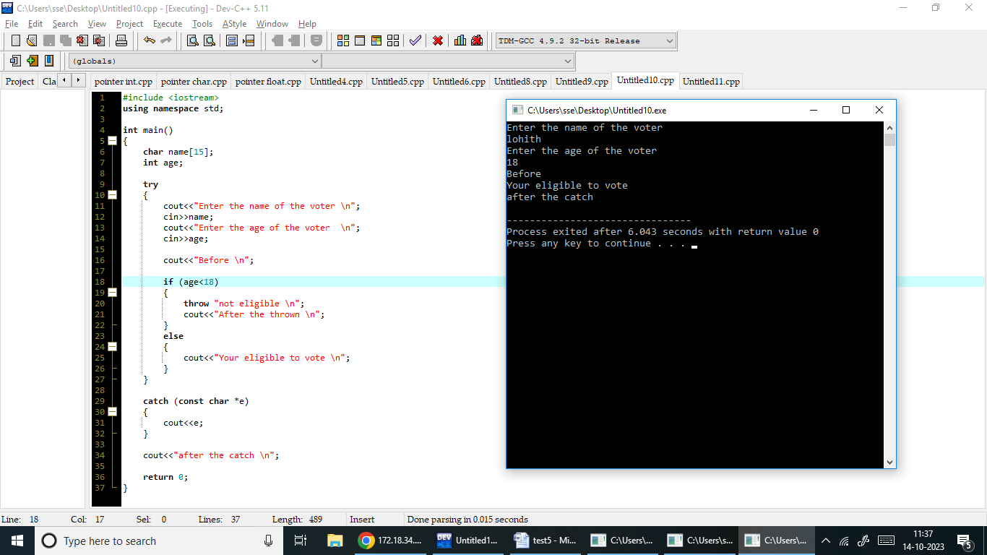

USING MULTIPLE CATCH

